Tax Gap Detection & Compliance Validation Service

1. Api call for Batch of Transactions Upload
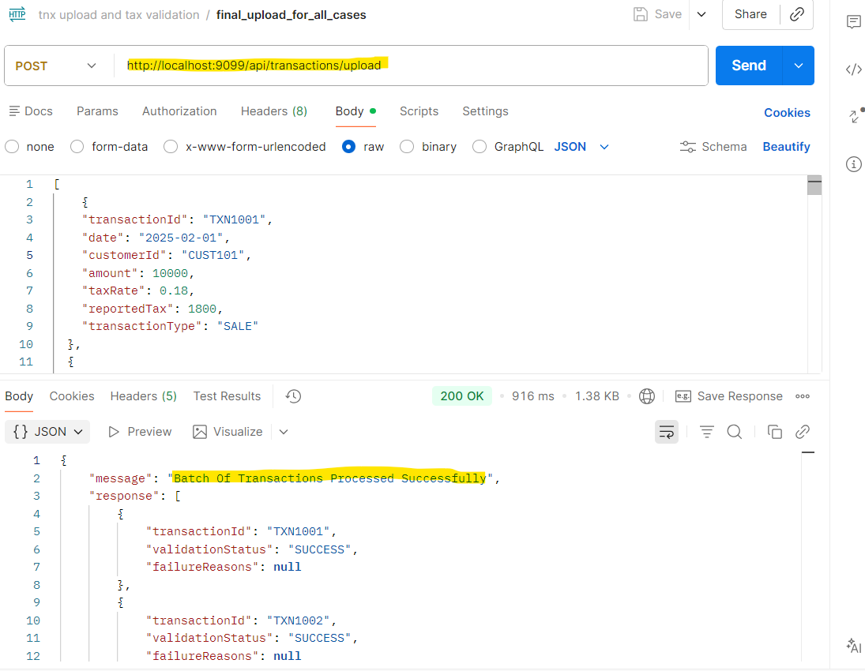
2. Api call for Empty-Transaction
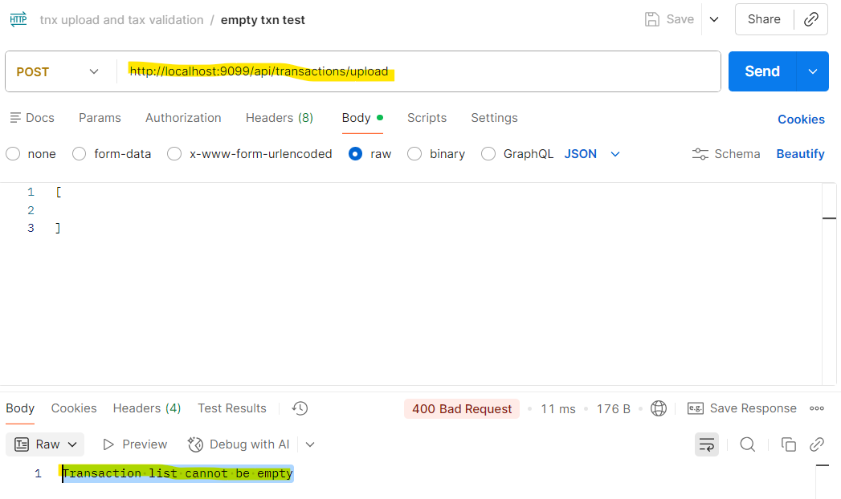
3.Api call for Duplicate Transaction
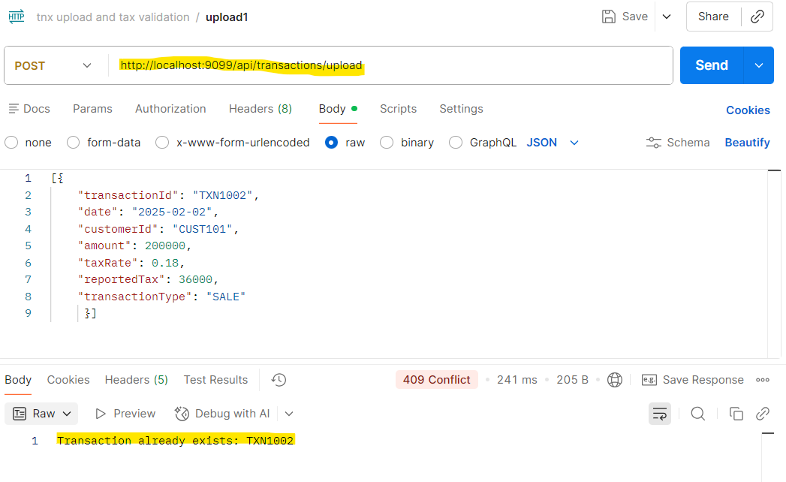
4.Api call for Invalid Date Format
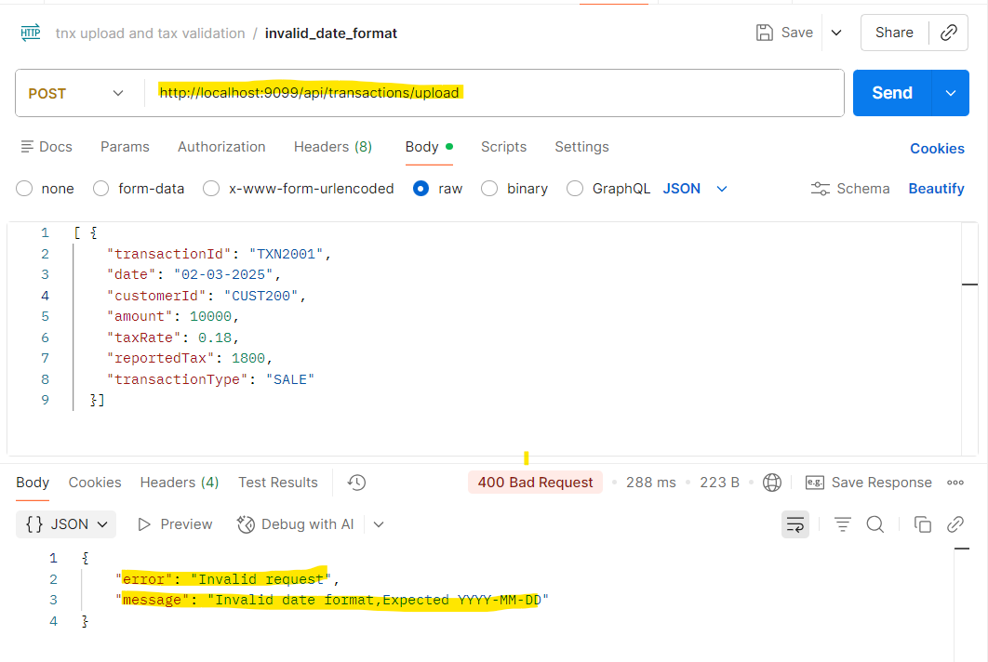

5.Api call for Missing Fields
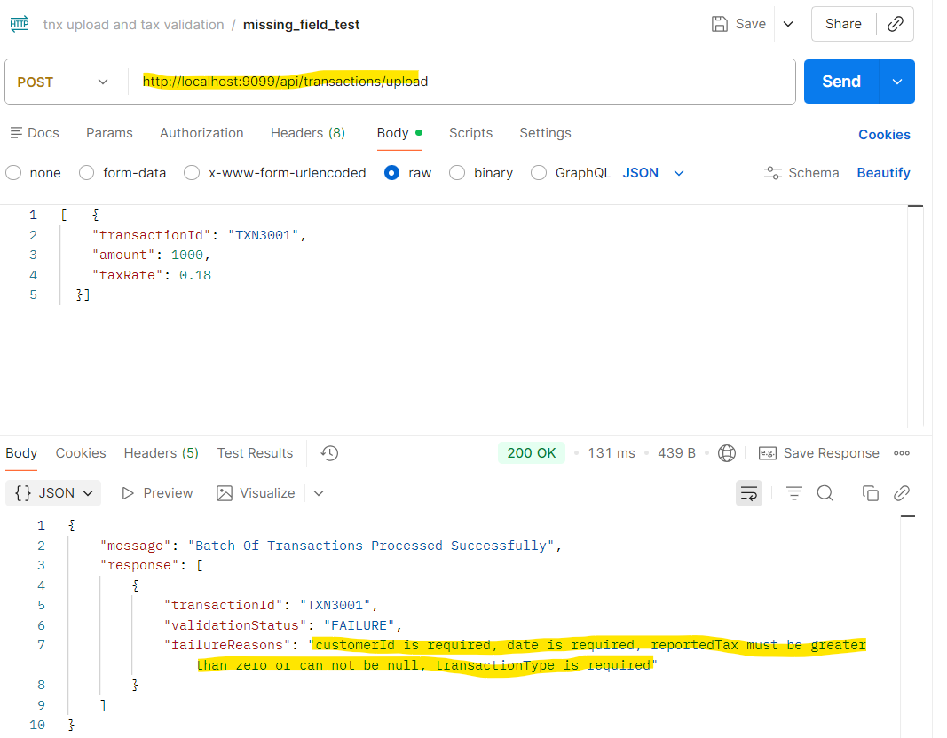
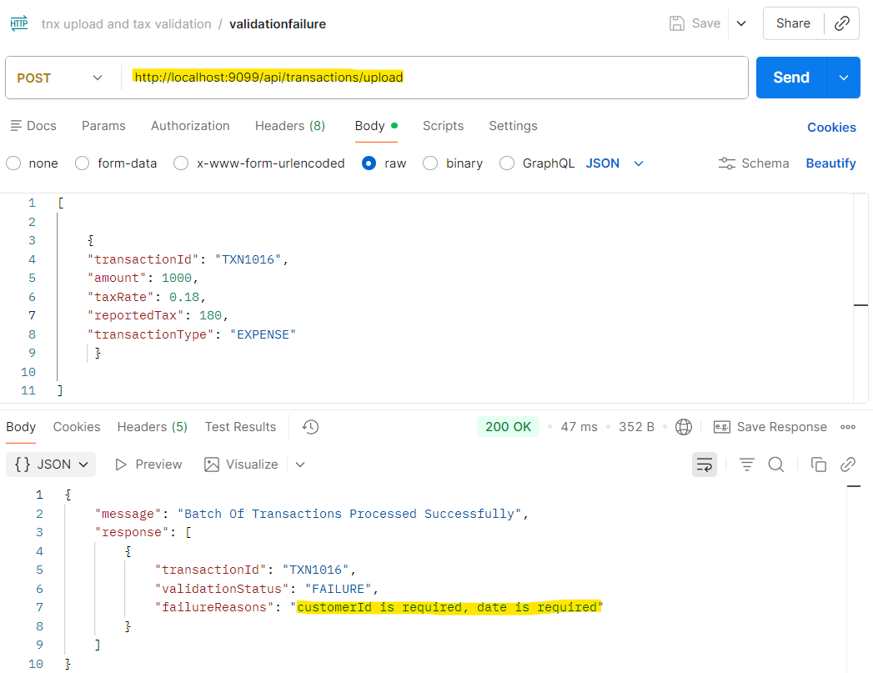

6.Api call for get all exceptions
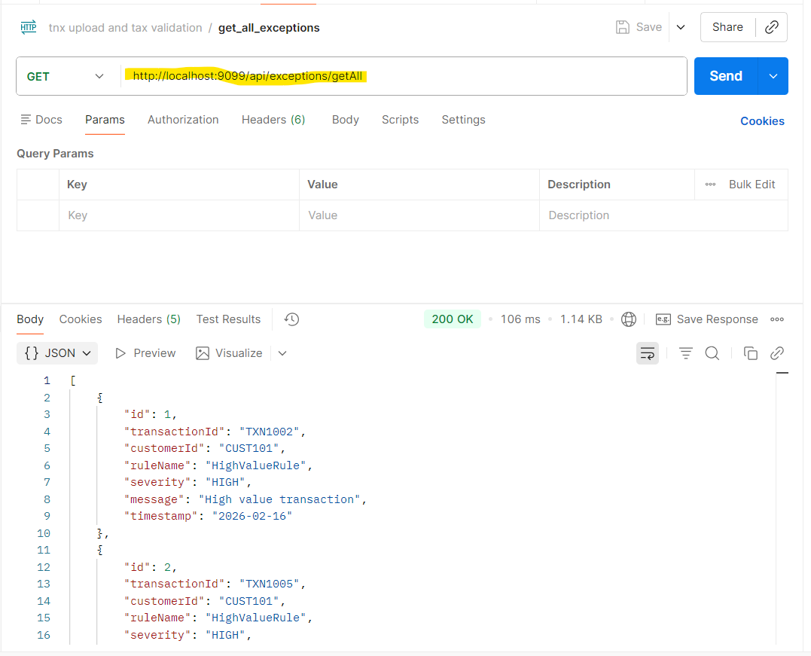
7.Filter Exceptions
Case-1: Api call for Filter Exception by customerid, severity, rulename
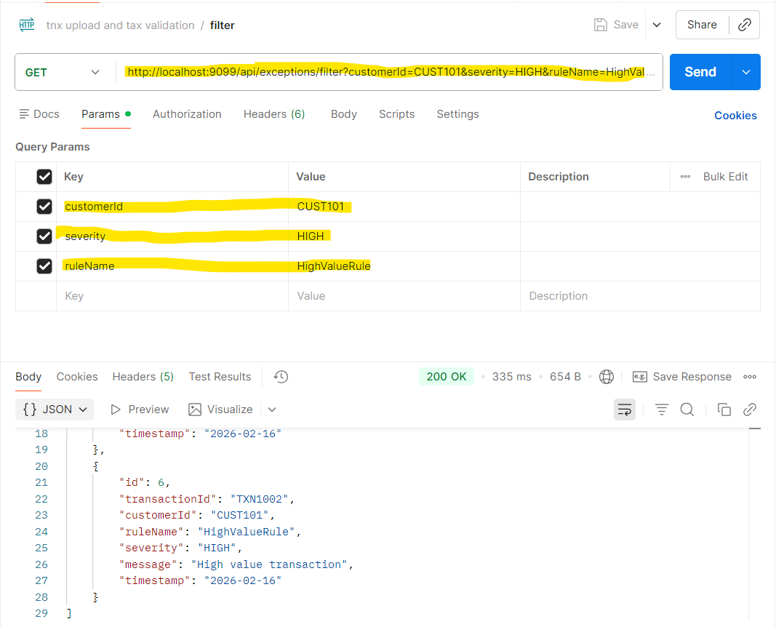
Case-2:Api call for filter exception by severity
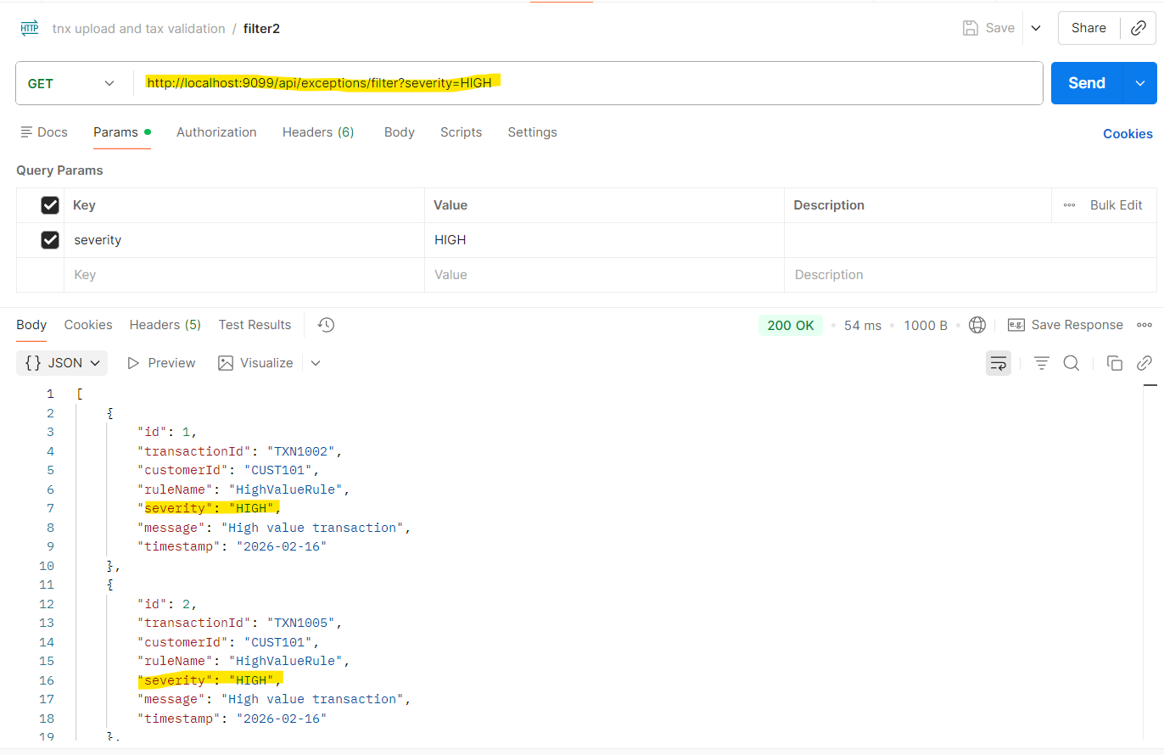
Case-3:Api call for filter exceptions by rulename
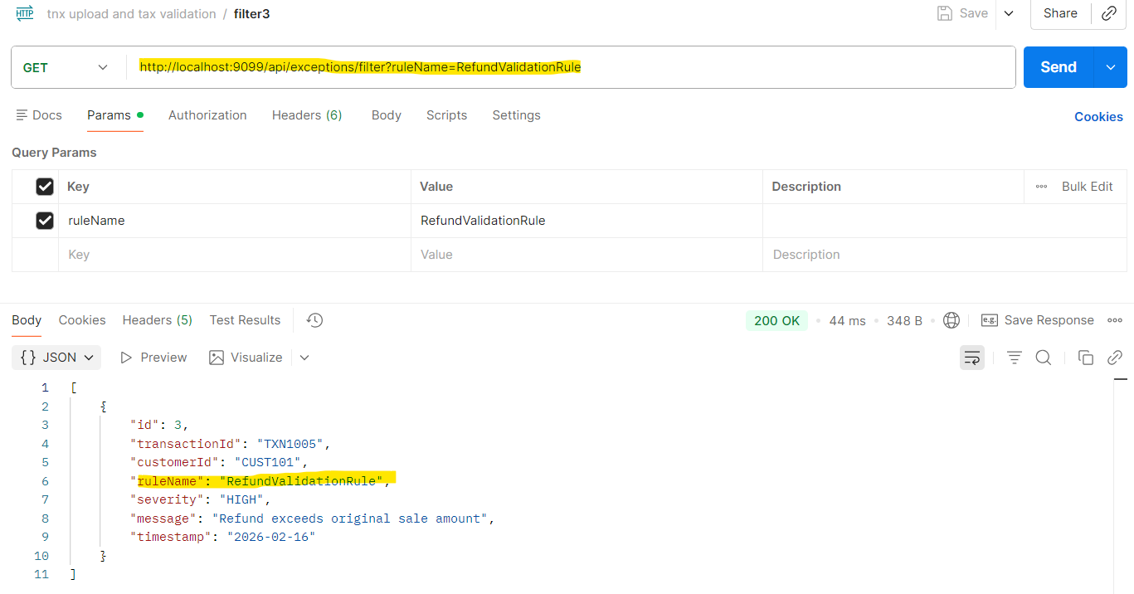

Case-4: Api call for filter exceptions by customerid
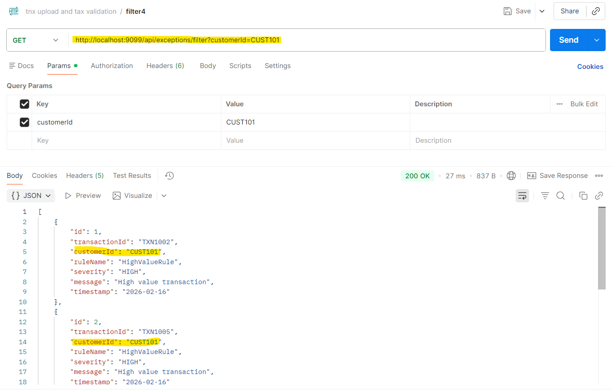
8. Api call for Customer tax summary report
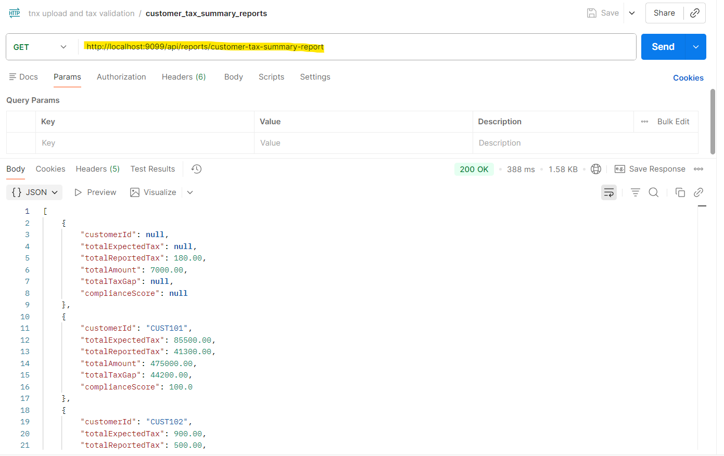

9. Api calls for Exception Reports
Case-1: Api call for count of total exceptions
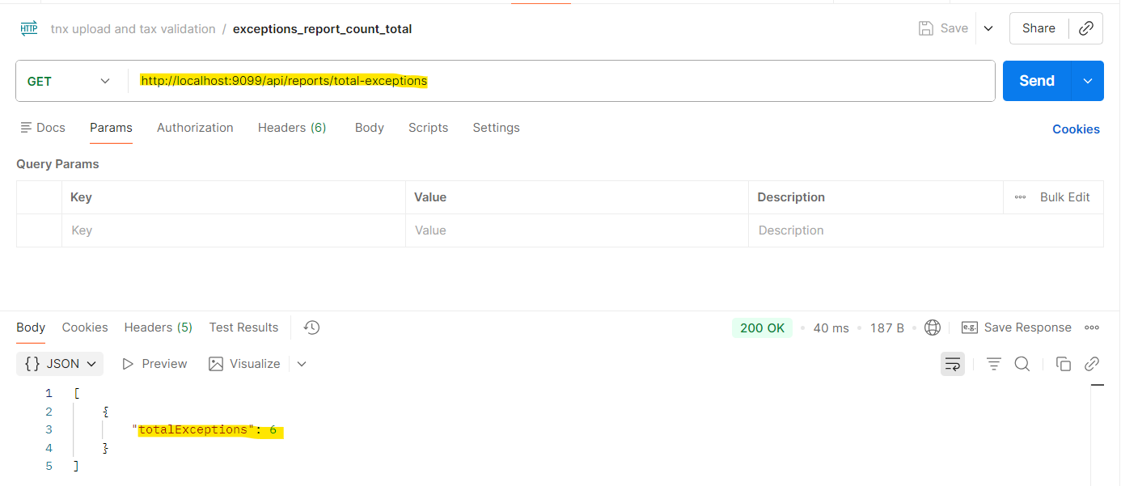
Case-2: Api call for Exception count by severity
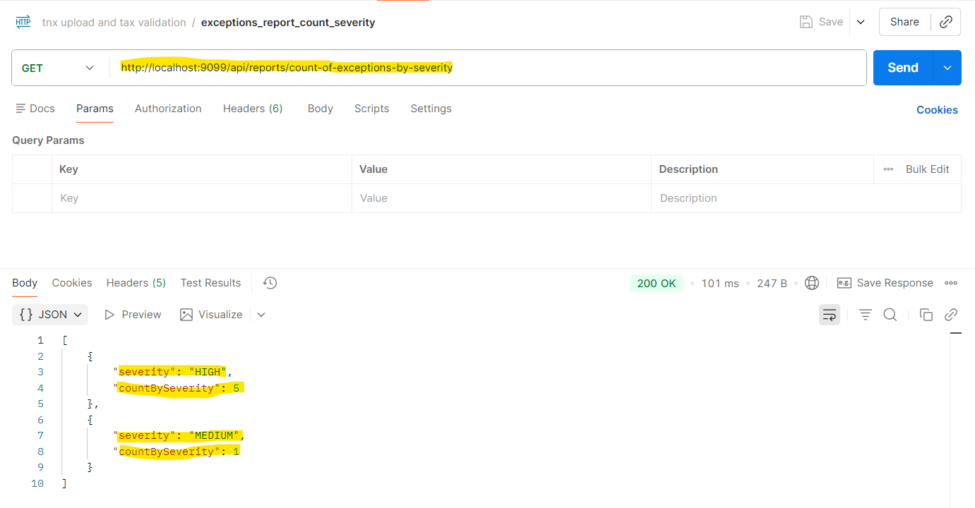

Case-3: Api call for Exception count by customer wise
